**DAILY ONLINE ACTIVITIES SUMMARY**

|  |  |  |  |  |  |  |  |
| --- | --- | --- | --- | --- | --- | --- | --- |
| **Date:** | 02/06/2020 | | | | **Name:** | AMBIKA V | |
| **Sem & Sec** | 4th SEM SEC 'A' | | | | **USN:** | 4AL18CS005 | |
| **Online Test Summary** | | | | | | | |
| **Subject** | |  | | | | | |
| **Max. Marks** | |  | | **Score** | |  | |
| **Certification Course Summary** | | | | | | | |
| **Course** |  | | | | | | |
| **Certificate Provider** | | | Greatlearning Academy | **Duration** | | | 7hrs |
| **Coding Challenges** | | | | | | | |
| **Problem Statement** **1:** Given an array array of size N and an integer K. The task is to find the count of subarrays such that each subarray has exactly K distinct elements.**Problem Statement 2:** Define a class Point with two fields x and y each of type double. Also , define a method distance(Point p1, Point p2) to calculate the distance between points p1 and p2 and return the value in double.. Use Math.sqrt( ) to calculate the square root. | | | | | | | |
| **Status:** Completed | | | | | | | |
| **Uploaded the report in Github** | | | | YES | | | |
| **If yes Repository name** | | | | https://github.com/ambika0202/lockdown-coding- | | | |
| **Uploaded the report in slack** | | | | YES | | | |

**Online Test Details:**

18MAT41(MATHS) I.A.3 was conducted on 01/06/2020 ..The total duration of the test was 40 min for 20 questions (MCQ) .The I.A had 2 tests .Test 1 had 10 questions each question carrying 1 mark and test 2 contained of 10 questions each question carrying 2 marks The portion for I.A. 3 was from Module-5

**Snapshot:**

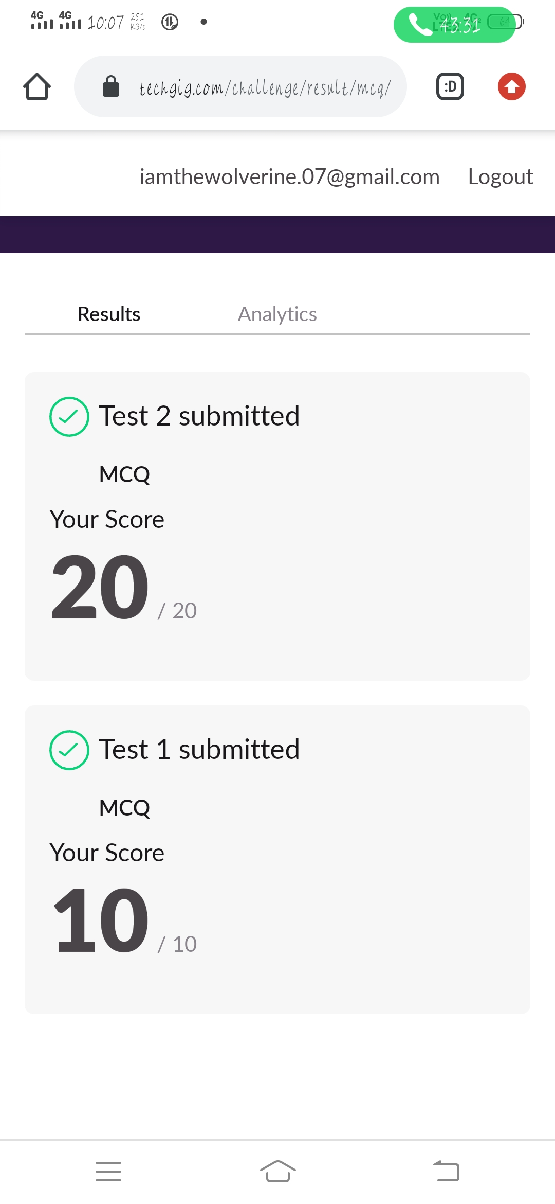

**Certification Course Details:**

**Name of the course**: Artificial intelligence in Python

**Certificate Provider**: Great Learning Academy

Python is a more popular language over C++ for AI and leads with a 57% vote among developers. That is because Python is easy to learn and implement. With its many libraries, they can also be used for data analysis. Performance wise C++ outperforms Python.

**Snapshot:**

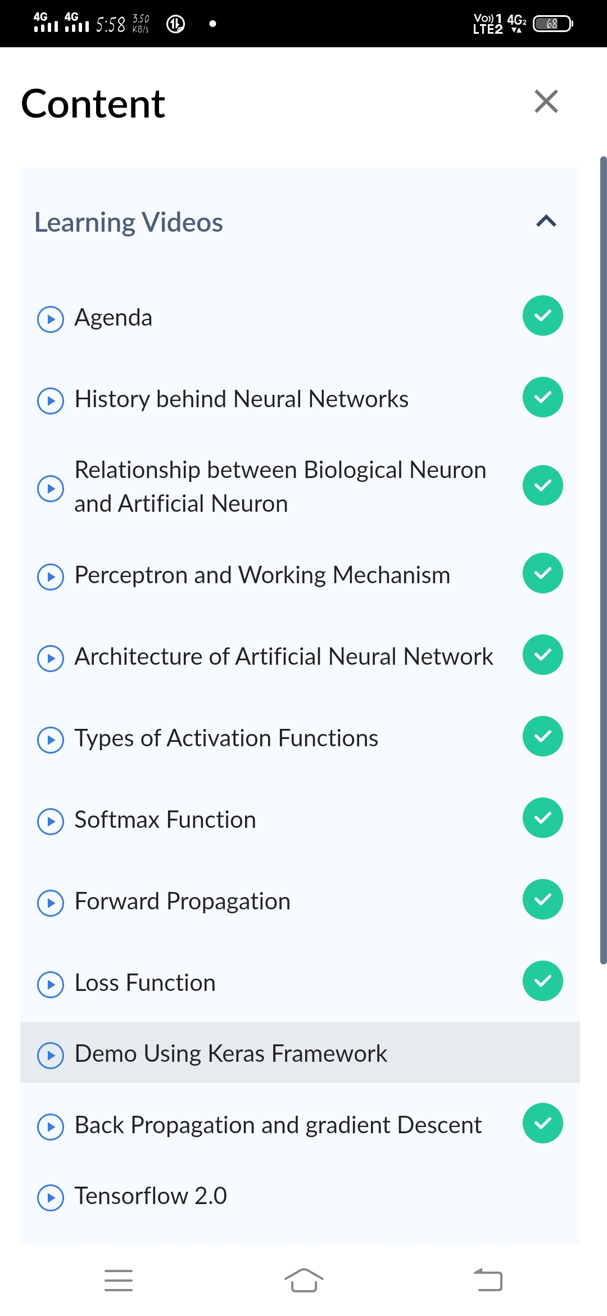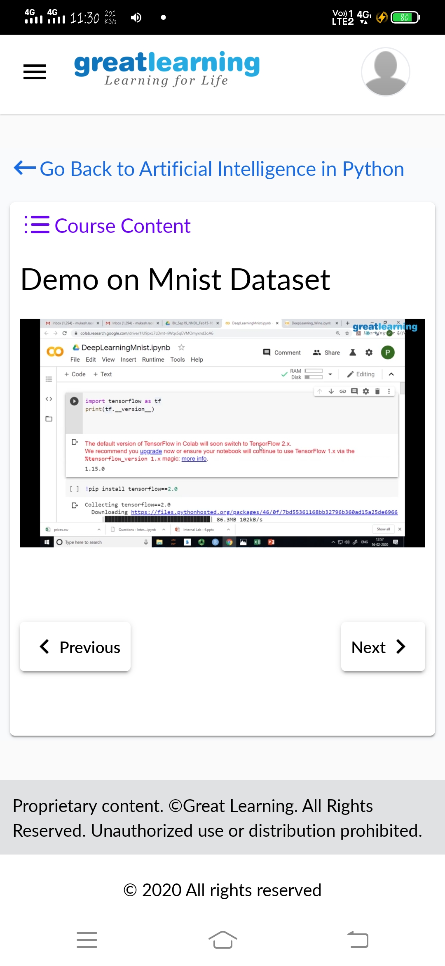

I have completed all the modules involved in Artificial intelligence in python and attempted the quiz and received its certificate successfully..

The below is the certificate issued by Great learning Academy.

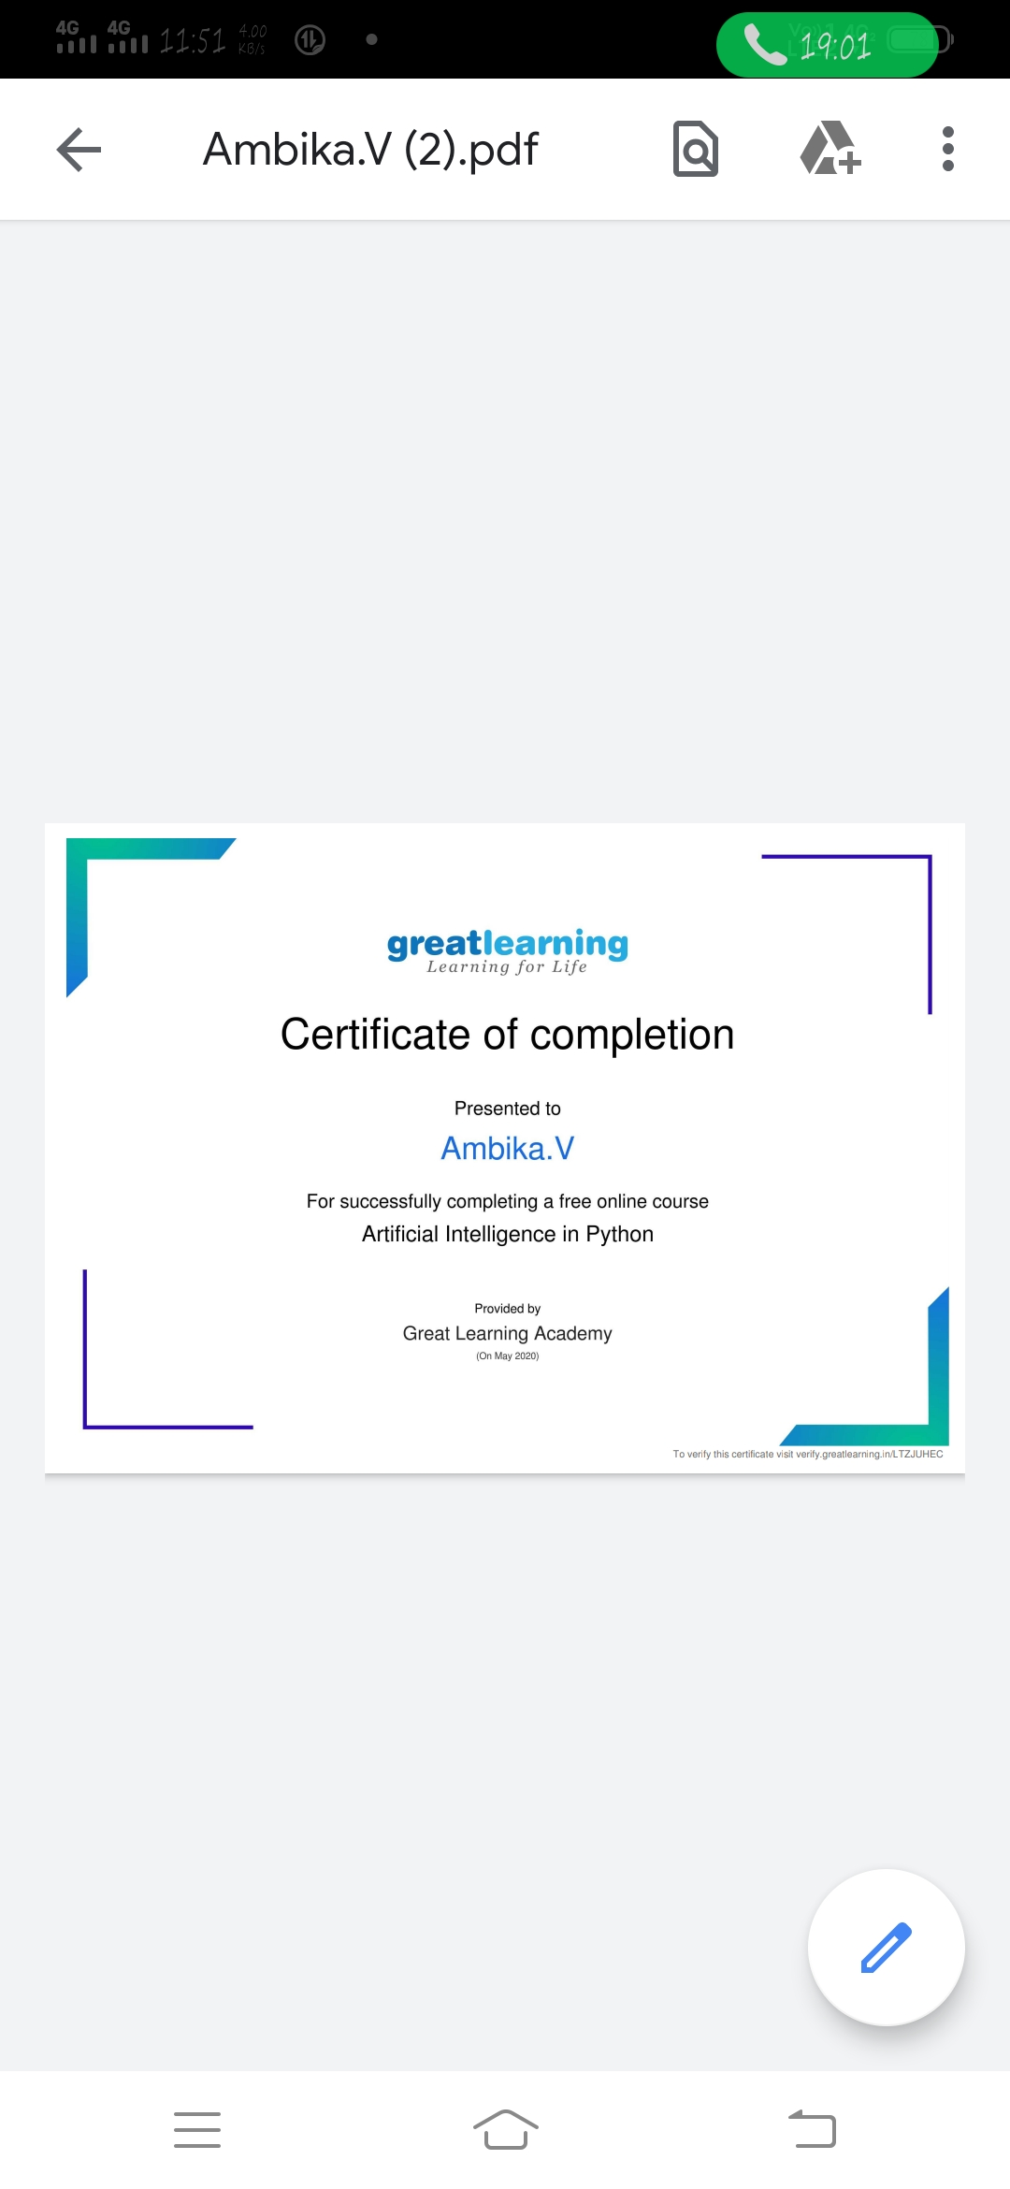

**Online Coding Details:**

**Problem statement 1:** Given an array array of size N and an integer K. The task is to find the count of subarrays such that each subarray has exactly K distinct elements.

**Snapshot:**

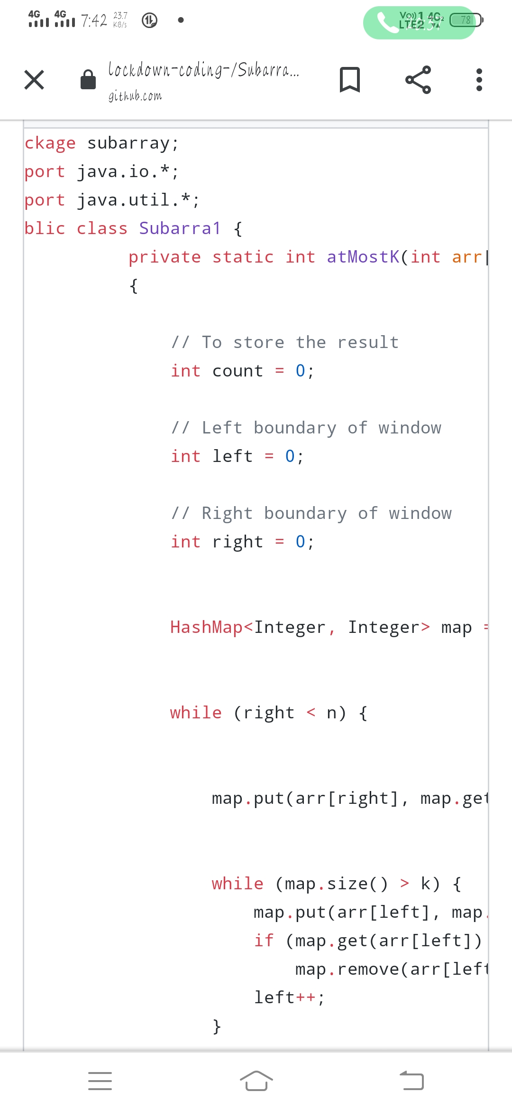

**Problem Statement 2:** Define a class Point with two fields x and y each of type double. Also , define a method distance(Point p1, Point p2) to calculate the distance between points p1 and p2 and return the value in double.. Use Math.sqrt( ) to calculate the square root.

**Snapshot :**

